Title of Paper: (centred, Title Case, no more than 12 words)

Author
Name of Affiliation, Country

Author
Name of Affiliation, Country

Abstract (250 words max.)

A concise and factual abstract is required (maximum length of 250 words). As far as possible, the abstract should state briefly the context of the research, the purpose of the research study, the methodology, the principal results and major conclusions and significance. It is understood that opinion articles, literature review articles and other non-empirical forms of study may necessitate slight changes in the abstract structure. An abstract is often presented separately from the article, so it must be able to stand alone. For this reason, references should be avoided, but if essential, then cite the author(s) and year(s). Acronyms should not be used. Also, non-standard or uncommon abbreviations should be avoided, but if essential they must be defined at their first mention in the abstract itself. The abstract should be one paragraph, single spaced and justified.

Keywords: (please provide at least three and no more than six keywords for the article)

NOTE: Only THREE heading levels are used –

Level 1: Centered, Bold, Title Case Heading

(e.g., Literature Review, Method, Findings, Discussion, Recommendations. Centred, Title Case)

Please note that the introduction does not have a heading. This is the introduction. Present purposes of the study and provide background for your work. The introduction should contain a clear statement of what the manuscript is about, why it is relevant, the purposes, background of the study, and general organisation of the remainder of the paper.

All body text is Times New Roman, 12 pt., justified and SINGLE SPACED. One line between paragraphs, no paragraph indents.

Your paper is 4000 – 7000 words excluding the title page, abstract and keywords, but including all in-text references and the reference list.

Lorem ipsum dolor sit amet, consectetur adipisicing elit, sed do eiusmod tempor incididunt ut labore et dolore magna aliqua. Ut enim ad minim veniam, quis nostrud exercitation ullamco laboris nisi ut aliquip ex ea commodo consequat. Duis aute irure dolor in reprehenderit in voluptate velit esse cillum dolore eu fugiat nulla pariatur.

Level 2: Subheading, Title Case (Left justified, bold. Title Case. Line space between subheading and following text)

Lorem ipsum dolor sit amet, consectetur adipisicing elit, sed do eiusmod tempor incididunt ut labore et dolore magna aliqua. Ut enim ad minim veniam, quis nostrud exercitation ullamco laboris nisi ut aliquip ex ea commodo consequat. Duis aute irure dolor in reprehenderit in voluptate velit esse cillum dolore eu fugiat nulla pariatur.

Level 3: Subheading, Title Case (Left justified, italics, bold, Title Case. Line space between subheading and following text)

Lorem ipsum dolor sit amet, consectetur adipisicing elit, sed do eiusmod tempor incididunt ut labore et dolore magna aliqua. Ut enim ad minim veniam, quis nostrud exercitation ullamco laboris nisi ut aliquip ex ea commodo consequat. Duis aute irure dolor in reprehenderit in voluptate velit esse cillum dolore eu fugiat nulla pariatur.

Tables and Figures

Table borders
Limit the use of borders or lines in a table to those needed for clarity. In general, use a border at the top and bottom of the table, beneath column headings (including decked heads), and above column spanners. You may also use a border to separate a row containing totals or other summary information from other rows in the table.
Do not use vertical borders to separate data, and do not use borders around every cell in a table. Use spacing between columns and rows and strict alignment to clarify relations among the elements in a table.
Table 1 (bold, left justified)
Regular Demographic/Informational Table (Title Case, italics, left justified)

Column Label | 1st Column | 2nd Column | 3rd Column | 4th Column
1st Row | x | x | x | x
2nd Row | x | x | x | x
3rd Row | x | x | x | x
4th Row | x | x | x | x
5th Row | x | x | x | x
6th Row | x | x | x | x
7th Row | x | x | x | x
Note. See APA manual beginning on p. 210 for additional examples.
Table 2
Chi-Square Sample Template

Source | Do not believe Unsure Believe  n % n % n % |  |  |  |  |  | X
x | x | x | x | x | x | x | x
x | x | x | x | x | x | x | x
x | x | x | x | x | x | x | x
x | x | x | x | x | x | x | x
x | x | x | x | x | x | x | x
Note. See APA manual p. 214 for table examples.

Table 3
Regression Sample Template
Variable | B | SE | t | p | %CI
x | 0.00  0.00 | 0.00  0.00 | 0.00  0.00 | 0.00  0.00 | [0.00, 0.00]  [0.00, 0.00]
x | 0.00  0.00 | 0.00  0.00 | 0.00  0.00 | 0.00  0.00 | [0.00, 0.00]  [0.00, 0.00]
x | 0.00  0.00 | 0.00  0.00 | 0.00  0.00 | 0.00  0.00 | [0.00, 0.00]  [0.00, 0.00]
x | 0.00  0.00 | 0.00  0.00 | 0.00  0.00 | 0.00  0.00 | [0.00, 0.00]  [0.00, 0.00]
x | 0.00  0.00 | 0.00  0.00 | 0.00  0.00 | 0.00  0.00 | [0.00, 0.00]  [0.00, 0.00]
x | 0.00  0.00 | 0.00  0.00 | 0.00  0.00 | 0.00  0.00 | [0.00, 0.00]  [0.00, 0.00]
Note. See APA manual beginning on p. 219 for more regression table examples.
Figure 1 (bold, left justified)
Sample Figure Title (Title Case, italics, left justified)

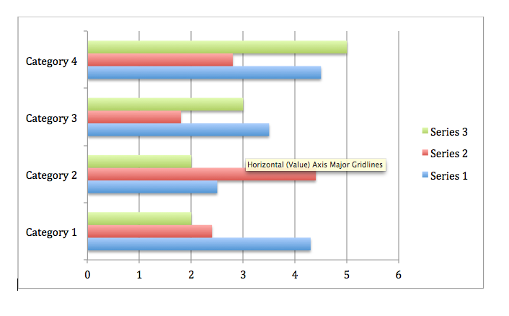

Conclusion

Lorem ipsum dolor sit amet, consectetur adipisicing elit, sed do eiusmod tempor incididunt ut labore et dolore magna aliqua. Ut enim ad minim veniam, quis nostrud exercitation ullamco laboris nisi ut aliquip ex ea commodo consequat. Duis aute irure dolor in reprehenderit in voluptate velit esse cillum dolore eu fugiat nulla pariatur. Excepteur sint occaecat cupidatat non proident, sunt in culpa qui officia deserunt mollit anim id est laborum. Lorem ipsum dolor sit amet, consectetur adipisicing elit, sed do eiusmod tempor incididunt ut labore et dolore magna aliqua. Ut enim ad minim veniam, quis nostrud exercitation ullamco laboris nisi ut aliquip ex ea commodo consequat. Duis aute irure dolor in reprehenderit in voluptate velit esse.
[Referencing to start on a new page]

In-Text Citations

When citing sources in-text, make sure you cite them after the first use, not at the end of the usage or paragraph.

One work by one or two authors:
(Author, year) or (Author & Author, year) for each citation.

One work by three or more authors:
(First Author et al., year)

Direct quotations:
If you use a direct quotation in your paper, you must say what page (p. #), if an article, or paragraph (para. #), if a website, the quotation came from. For audiobooks or podcasts use the time of the quote in (00:00) format. For eBooks, use the location number if no page number available (loc. #).

References (add full DOIs where available – check google, journal websites)

Cameron, D. (2001). Working with spoken discourse. London: SAGE.
Coates, J. (2007). Talk in a play frame: More on laughter and intimacy. Journal of Pragmatics, 39, 29–49. https://doi.org/10.1016/j.pragma.2006.05.003
Drew P., & Heritage J. (1992). Analysing talk at work: An introduction. In P. Drew, & J. Heritage (Eds.), Talk at work (pp. 3–65). Cambridge: Cambridge University Press.

To find out how to reference other print sources, electronic sources and non-print sources, see here: https://owl.english.purdue.edu/owl/resource/560/05/

References are single spaced, Times New Roman 12 pt., left align, hanging indent 1.27cm, 6pt spacing between references after first line. Do not use tabs or spaces to indent the references, use the paragraph formatting for hanging indent.

Corresponding author: [author name]
Email: example@iafor.edu
Document updated January 7, 2022

