Title of Paper: (centred, headline style capitalization, no more than 12 words)

Author
Name of Affiliation
Country

Author
Name of Affiliation
Country

Abstract (250 words max.)

A concise and factual abstract is required (maximum length of 250 words). As far as possible, the abstract should state briefly the context of the research, the purpose of the research study, the methodology, the principal results and major conclusions and significance. It is understood that opinion articles, literature review articles and other non-empirical forms of study may necessitate slight changes in the abstract structure. An abstract is often presented separately from the article, so it must be able to stand alone. For this reason, references should be avoided, but if essential, then cite the author(s) and year(s). Acronyms should not be used. Also, non-standard or uncommon abbreviations should be avoided, but if essential they must be defined at their first mention in the abstract itself. The abstract should be one paragraph, single spaced and justified.

Keywords: (please provide at least three and no more than six keywords for the article)

Main Section Heading

(e.g., Literature review, Method, Findings, Discussion, Recommendations. Centred, headline capitalisation)

Please note that the introduction does not have a heading. This is the introduction. Present purposes of the study and provide background for your work. The introduction should contain a clear statement of what the manuscript is about, why it is relevant, the purposes, background of the study, and general organisation of the remainder of the paper.

All body text is Times New Roman, 12 pt., justified. One line between paragraphs, no paragraph indents.

Your paper is 4000 – 7000 words excluding the title page, abstract and keywords, but including all in-text references and the reference list.

Lorem ipsum dolor sit amet, consectetur adipisicing elit, sed do eiusmod tempor incididunt ut labore et dolore magna aliqua. Ut enim ad minim veniam, quis nostrud exercitation ullamco laboris nisi ut aliquip ex ea commodo consequat. Duis aute irure dolor in reprehenderit in voluptate velit esse cillum dolore eu fugiat nulla pariatur.

Subheading (Left justified, bold. No line space between subheading and following text)
Lorem ipsum dolor sit amet, consectetur adipisicing elit, sed do eiusmod tempor incididunt ut labore et dolore magna aliqua. Ut enim ad minim veniam, quis nostrud exercitation ullamco laboris nisi ut aliquip ex ea commodo consequat. Duis aute irure dolor in reprehenderit in voluptate velit esse cillum dolore eu fugiat nulla pariatur.

Sub-subheading. (Bold, text follows directly after on the same line) Lorem ipsum dolor sit amet, consectetur adipisicing elit, sed do eiusmod tempor incididunt ut labore et dolore magna aliqua. Ut enim ad minim veniam, quis nostrud exercitation ullamco laboris nisi ut aliquip ex ea commodo consequat. Duis aute irure dolor in reprehenderit in voluptate velit esse cillum dolore eu fugiat nulla pariatur.

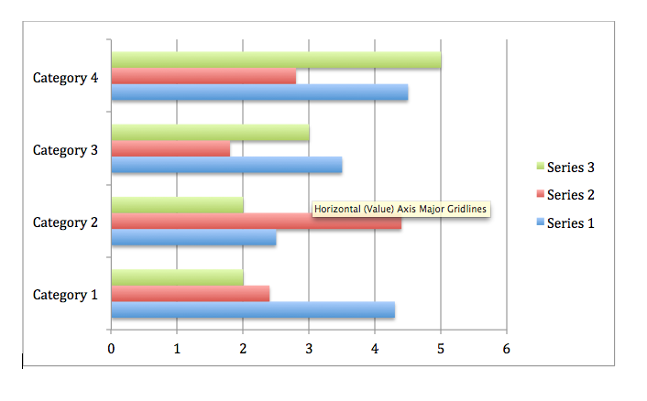
Figure 1: Caption (centred below the figure, first word capitalisation. Ensure figures are clear, relevant and legible)

Table 1: Caption (centred above the table, first word capitalisation)

 | X | Y | Z
A
B
C

Conclusion

Lorem ipsum dolor sit amet, consectetur adipisicing elit, sed do eiusmod tempor incididunt ut labore et dolore magna aliqua. Ut enim ad minim veniam, quis nostrud exercitation ullamco laboris nisi ut aliquip ex ea commodo consequat. Duis aute irure dolor in reprehenderit in voluptate velit esse cillum dolore eu fugiat nulla pariatur. Excepteur sint occaecat cupidatat non proident, sunt in culpa qui officia deserunt mollit anim id est laborum. Lorem ipsum dolor sit amet, consectetur adipisicing elit, sed do eiusmod tempor incididunt ut labore et dolore magna aliqua. Ut enim ad minim veniam, quis nostrud exercitation ullamco laboris nisi ut aliquip ex ea commodo consequat. Duis aute irure dolor in reprehenderit in voluptate velit esse.
[Referencing to start on a new page]

References (add full DOIs where available – check google, journal websites)

Cameron, D. (2001). Working with spoken discourse. London: SAGE.
Coates, J. (2007). Talk in a play frame: More on laughter and intimacy. Journal of Pragmatics, 39, 29–49. https://doi.org/10.1016/j.pragma.2006.05.003
Drew P., & Heritage J. (1992). Analysing talk at work: An introduction. In P. Drew, & J. Heritage (Eds.), Talk at work (pp. 3–65). Cambridge: Cambridge University Press.

To find out how to reference other print sources, electronic sources and non-print sources, see here: https://owl.english.purdue.edu/owl/resource/560/05/

References are single spaced, Times New Roman 12 pt., left align, hanging indent 1.27cm after first line. Do not use tabs or spaces to indent the references, use the paragraph formatting for hanging indent.

Corresponding author: [author name]
Contact email: example@iafor.edu
Document updated March 5, 2020

